**EXECUTIVE REPORT**

**Esteemed members of the board,**

Hold onto your hats, because we're about to embark on a thrilling adventure through the world of marketing analytics! As the leader of the team, I'm here to share with you some exciting news: we've got the data, the insights, and the strategies to boost our sales like never before. And not just any sales, but the sales of specific subcategories that's been itching for some attention. So buckle up, sit back, and get ready to witness the power of marketing analytics at its finest!

Let me introduce you to our superstar salesperson, Anna Andreadi, who has been crushing it in the West Region! With her impressive sales skills and sharp instincts, Anna has generated a whopping profit of 108,418 $, leaving her counterparts Chuck Magee, Cassandra Brandow, Kelly Williams in the dust [1]. And it's no surprise that she sold the most number of copiers (25), our STAR product as per the BCG growth share matrix [2]. Copiers are the golden goose of our subcategories, with an average profit margin of 817.9$, much higher than the next best Accessories (54.1), phones (50.1), etc. making it a dream product for any salesperson [3]. Interesting to note that copiers generated a cumulative profit of 25,032$ in 2019 compared to 2,913$ in 2016. That’s a whopping 760.43% increase in profits. Similarly, they showed a 479.71% increase in sales during the same period. With sales and profits soaring like this, we might need to start calling them "money printers" instead of copiers! [4]

Moreover, Anna made a whopping 3,203 orders, topping the charts amongst her fellow salespeople. On the other hand, Cassandra fulfilled 1,620 orders, which is almost half the orders managed by Anna [5]. I would recommend the management to give Cassandra the boost she needs to become a sales superstar! Though she fulfilled a respectable number of orders, we know she has the potential to do even better. Firstly, the company can organize a friendly competition between all the salespeople. The competition will be fierce, but the rewards will be even better - a fully paid vacation to an exotic destination like Hawaii! To help Cassandra stay on top of her game, the company can offer her personalized coaching and mentorship from some of the most successful salespeople. She'll learn all the tips and tricks to improve her sales skills and build better relationships with customers. With the fun and engaging approach to sales, we know Cassandra will flourish and exceed her wildest expectations.

Speaking of orders, it's interesting to note that most orders were fulfilled during the festive months of November (1,471) and December (1,408) in the US [6]. It's no secret that these months are filled with joy and merriment, and it seems like people can't resist splurging on some fantastic deals! The splurge in orders could have been due to the irresistible temptation of Black Friday, the online shopping frenzy of Cyber Monday, the gift-giving extravaganza of Christmas, the last-minute End-of-Year Sales or the fresh start of the New Year. [Ref - 1]

Now, get ready to be wowed by our top-selling subcategory, Binders, with a massive 1523 units sold and total profits of 30,222 $, followed by paper with 1,370 units and profits of 34,054$. Despite some shining stars in our sales data, we also have some duds that are weighing us down like Tables, Bookcases, Supplies, Fasteners, and Machines. These under-performing subcategories have total profits less than 5000$, with some even in the negative zone like tables, bookcases, supplies with tables generating a huge loss of 17,725$. [7]

Talking about discounts, Machines might have a discount rate of 30%, just behind binders with 37% but that's not enough to make up for their lack of popularity. With just 115 units sold and a total profit of 3,385 $, it's safe to say that Machines aren’t the hottest chick in the town [8]. And if that's not enough to make you think twice, the Cubify CubeX 3D Printer Double Head Print, belonging to machines, has been the biggest loser with 9 units sold at a cumulative loss of 8,800$, making it the worst performing product! [9]

Thus, I feel It's time to say goodbye to these under-performers! I strongly advise the management to discontinue the sales of tables, bookcases, supplies, fasteners, and machines, and shift focus to the top-performing products that are bringing in the big bucks.

Looking at our shipping modes, it's no surprise that the majority of our orders are fulfilled using the Standard class option, with 5,968 orders. This shipping mode may be a popular choice for our customers since our products belong to the furniture, office supplies, and technology categories that may not require immediate delivery. However, same-day shipping has the least number of orders, with only 543 orders [10]. One reason for this could be the high shipping costs associated with this option. Interestingly despite being the fastest shipping mode, Same-Day shipping had the highest return percentage of 11.78% amongst other shipping modes [11]. This could be due to the high expectations associated with speedy delivery, which can lead to disappointment if the order doesn't arrive on time. Additionally, the rush to deliver products on the same day may increase the chances of damage or defects, contributing to the higher return rate. So, while Same-Day shipping may seem like a great option for those in a hurry, it's important to weigh the potential drawbacks associated with it.

Although shipping speed can impact customer satisfaction, it's not the only factor that can affect business performance. In addition to analyzing shipping modes, I also conducted a thorough analysis of the sales and profit data. The scatter plot revealed a moderate positive correlation between sales and profit, with a correlation coefficient of 0.46. This suggests that as sales increase, profit also tends to increase. Furthermore, the p-value less than 0.0001 indicates that this relationship is statistically significant and not just a fluke. However, what really caught my attention were the outliers in the scatterplot, particularly the Canon imageCLASS 2200 Advanced Copier. With its units generating a massive profit of $8,400, $6,720 and $3,920 it is clear that this product is a real money maker for us. Therefore, I strongly recommend that we add more of this product to our portfolio and ramp up sales in order to maximize the profits. On the flip side, it is evident that some products in the machine subcategory are causing us significant losses. For instance, the Cubify CubeX 3D Printer Double Head Print, Cubify CubeX 3D Printer Triple Head Print, and Cisco TelePresence System EX90 Video conferencing unit are bringing in huge losses of -$6,600, -$3,840, and -$1,811 respectively. In light of this, I would recommend that we remove these products from our portfolio in order to mitigate our losses. [12]

But it's not just the product portfolio that's impacting our performance. The location of our customers also plays a crucial role. California, the Golden State, has taken the US sales market by storm, outshining all the other states in total sales revenue, profits, and the number of orders being fulfilled. But why has California left the rest of the country in its dust? Well, for starters, it is the most populous state in the US, with a whopping 39 million people [Ref - 2]. With such a massive population, California has a significant edge in terms of having a larger customer base, ultimately resulting in increased sales revenue. Not to mention, California has the largest economy in the US and is the fifth-largest economy globally. The booming economy implies that Californians have more money to burn, and as a result, more disposable income to purchase products. [Ref - 3] So, the next time you think of California, remember, it's not only about the palm trees, beaches, and Hollywood glamor, but also about being our sales superstar, our MVP in the US!

Overall, the business has been on an upward trajectory in the past four years, as indicated by our impressive growth in sales, profits, and order fulfillment. In fact, our sales revenue alone has soared to new heights, boasting an astonishing 51.5% increase from 2016 to 2019! Not only that, but our profits have also experienced a meteoric rise, showing an incredible 88.51% increase over the same period. And if that's not enough, our order fulfillment has increased by a whopping 66.19%, indicating that our customers' trust and loyalty have reached new heights. This tremendous success is a testament to our unwavering commitment to quality, customer satisfaction, and business excellence. Let's keep pushing forward and build on this incredible momentum!

Uh-oh, looks like I've maxed out my word count. But hey, that's just a sign of how passionate I am about helping you! So feel free to reach out to me anytime for additional support.

Thank You,

Abhishek Rathi

Marketing Analyst

Dubai

Email - [arathi1@student.hult.edu](mailto:arathi1@student.hult.edu)

**APPENDIX**

**Storytelling Canvas**

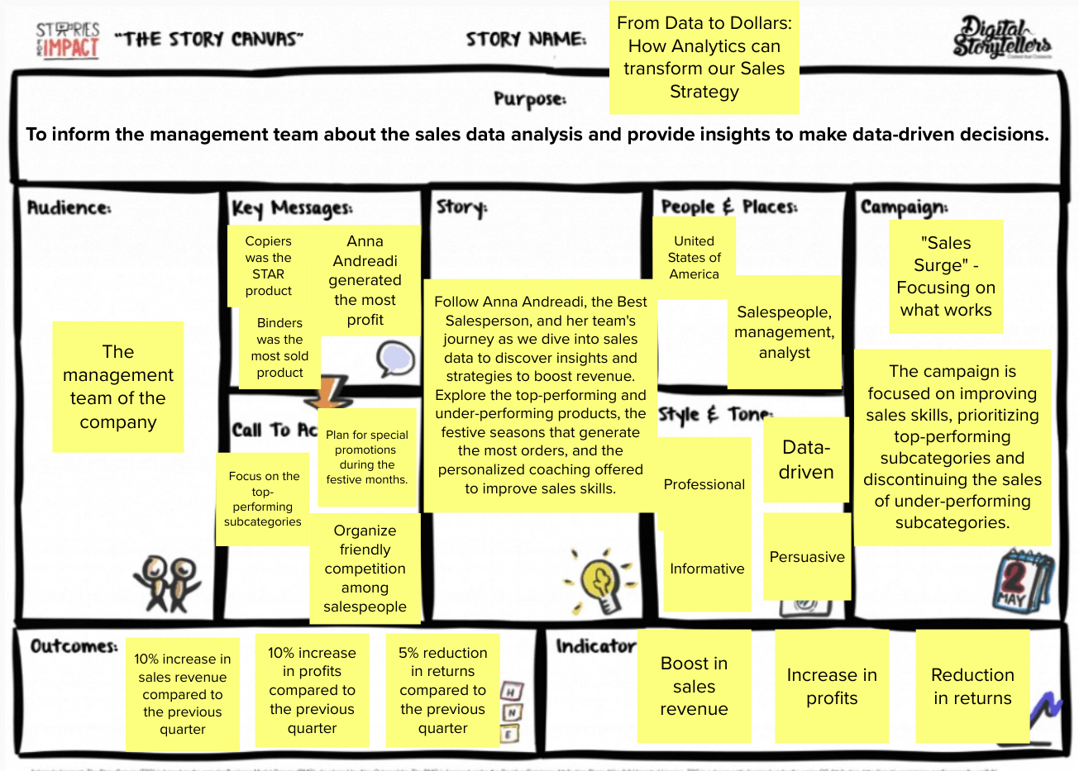

**SHEETS**

**[1] Total profits generated by each Salesperson**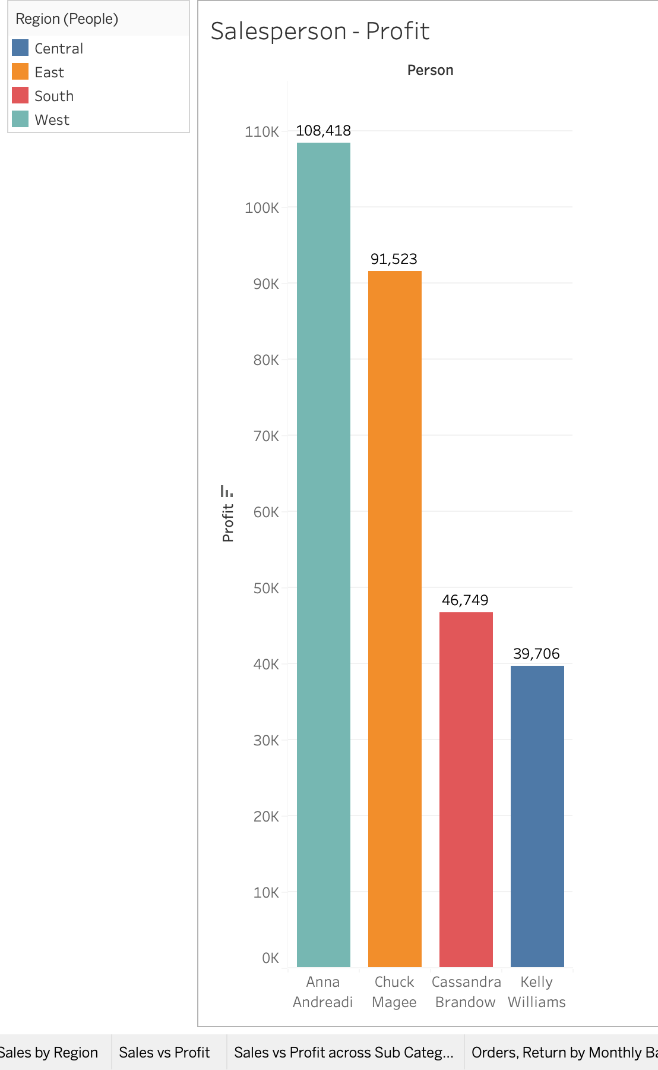

**[2] Total no. of orders of Copiers fulfilled by Salesperson**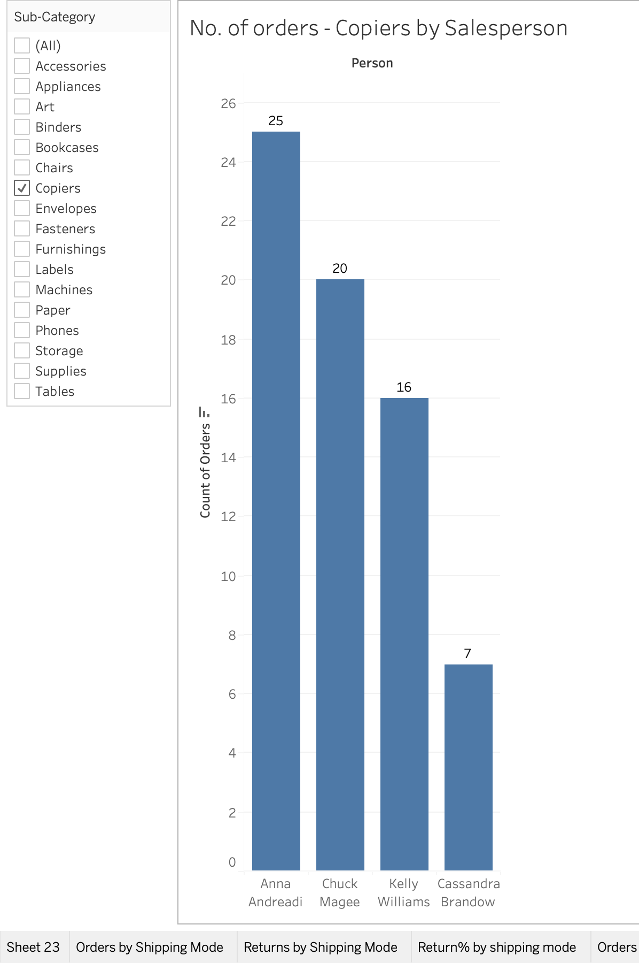

**[3] Average profit margin by Sub-Category**

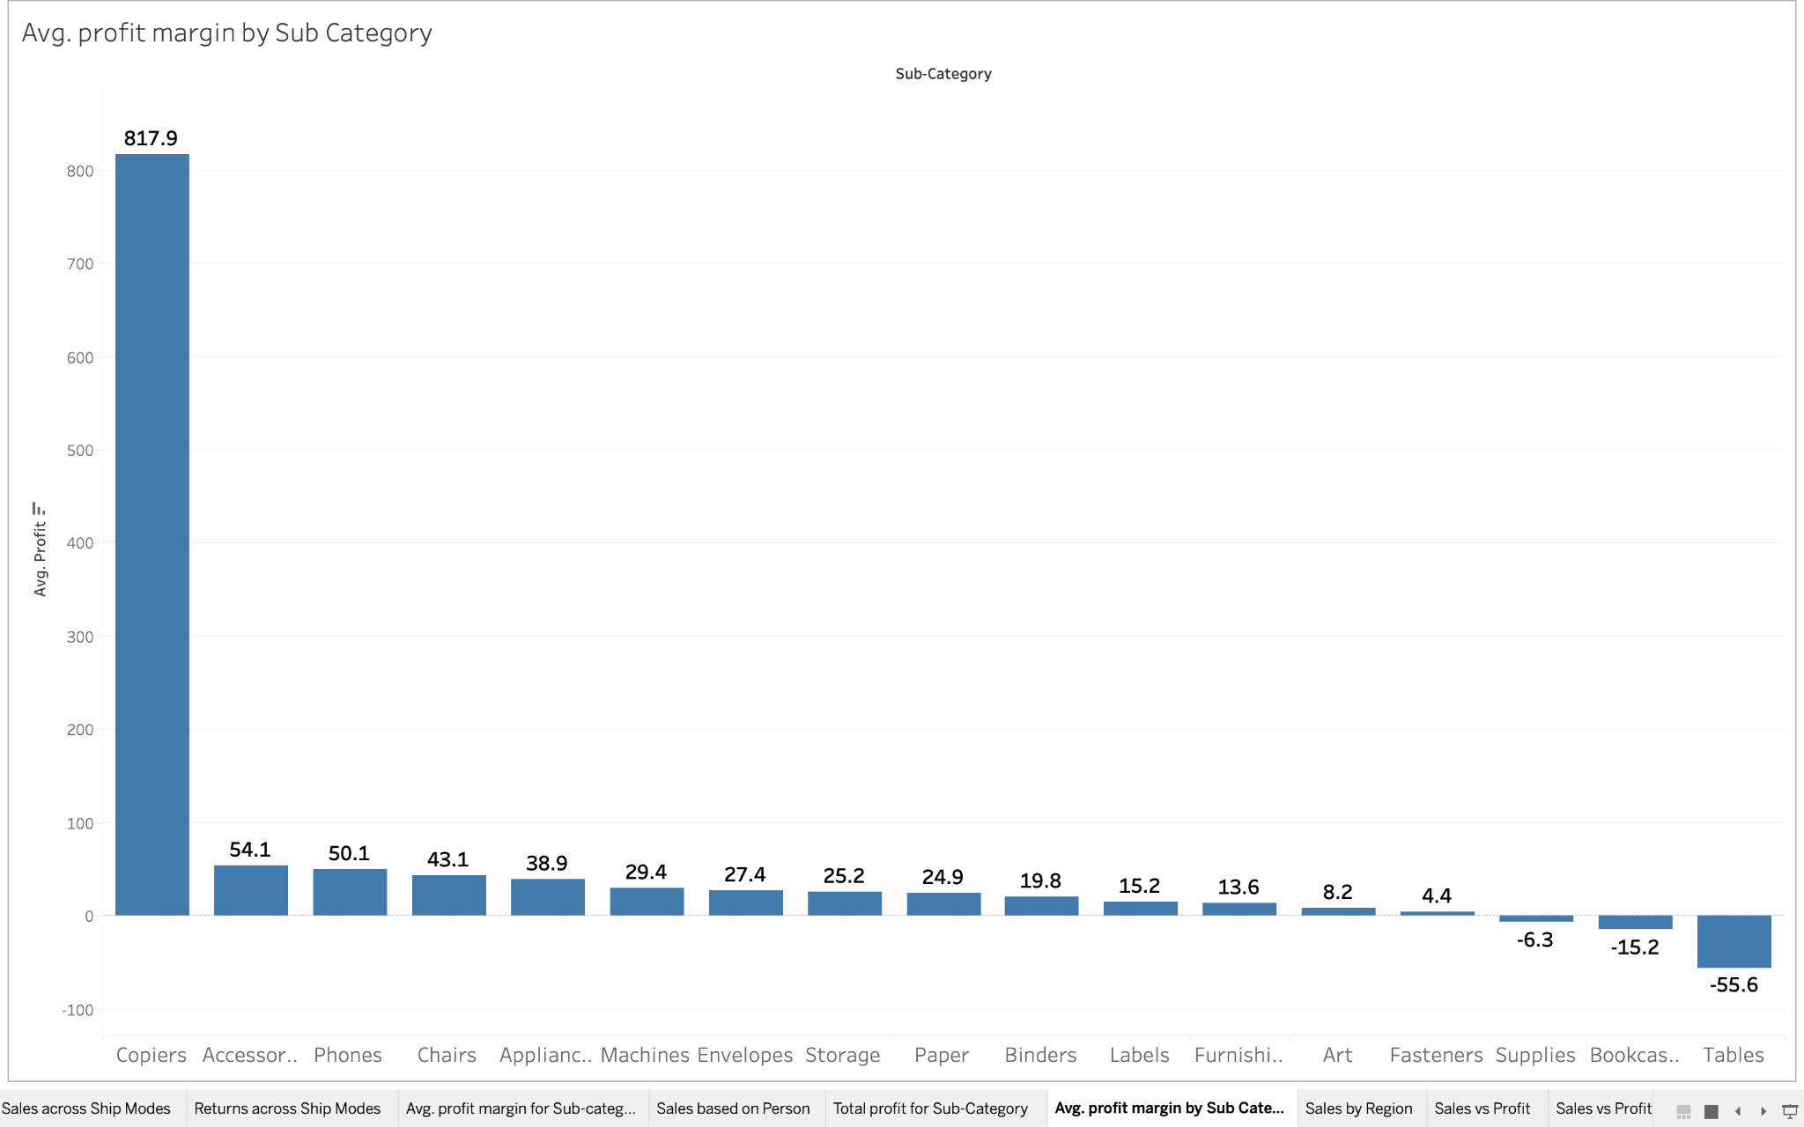

**[4] Sales, Profits Year-over-year growth for Copiers**

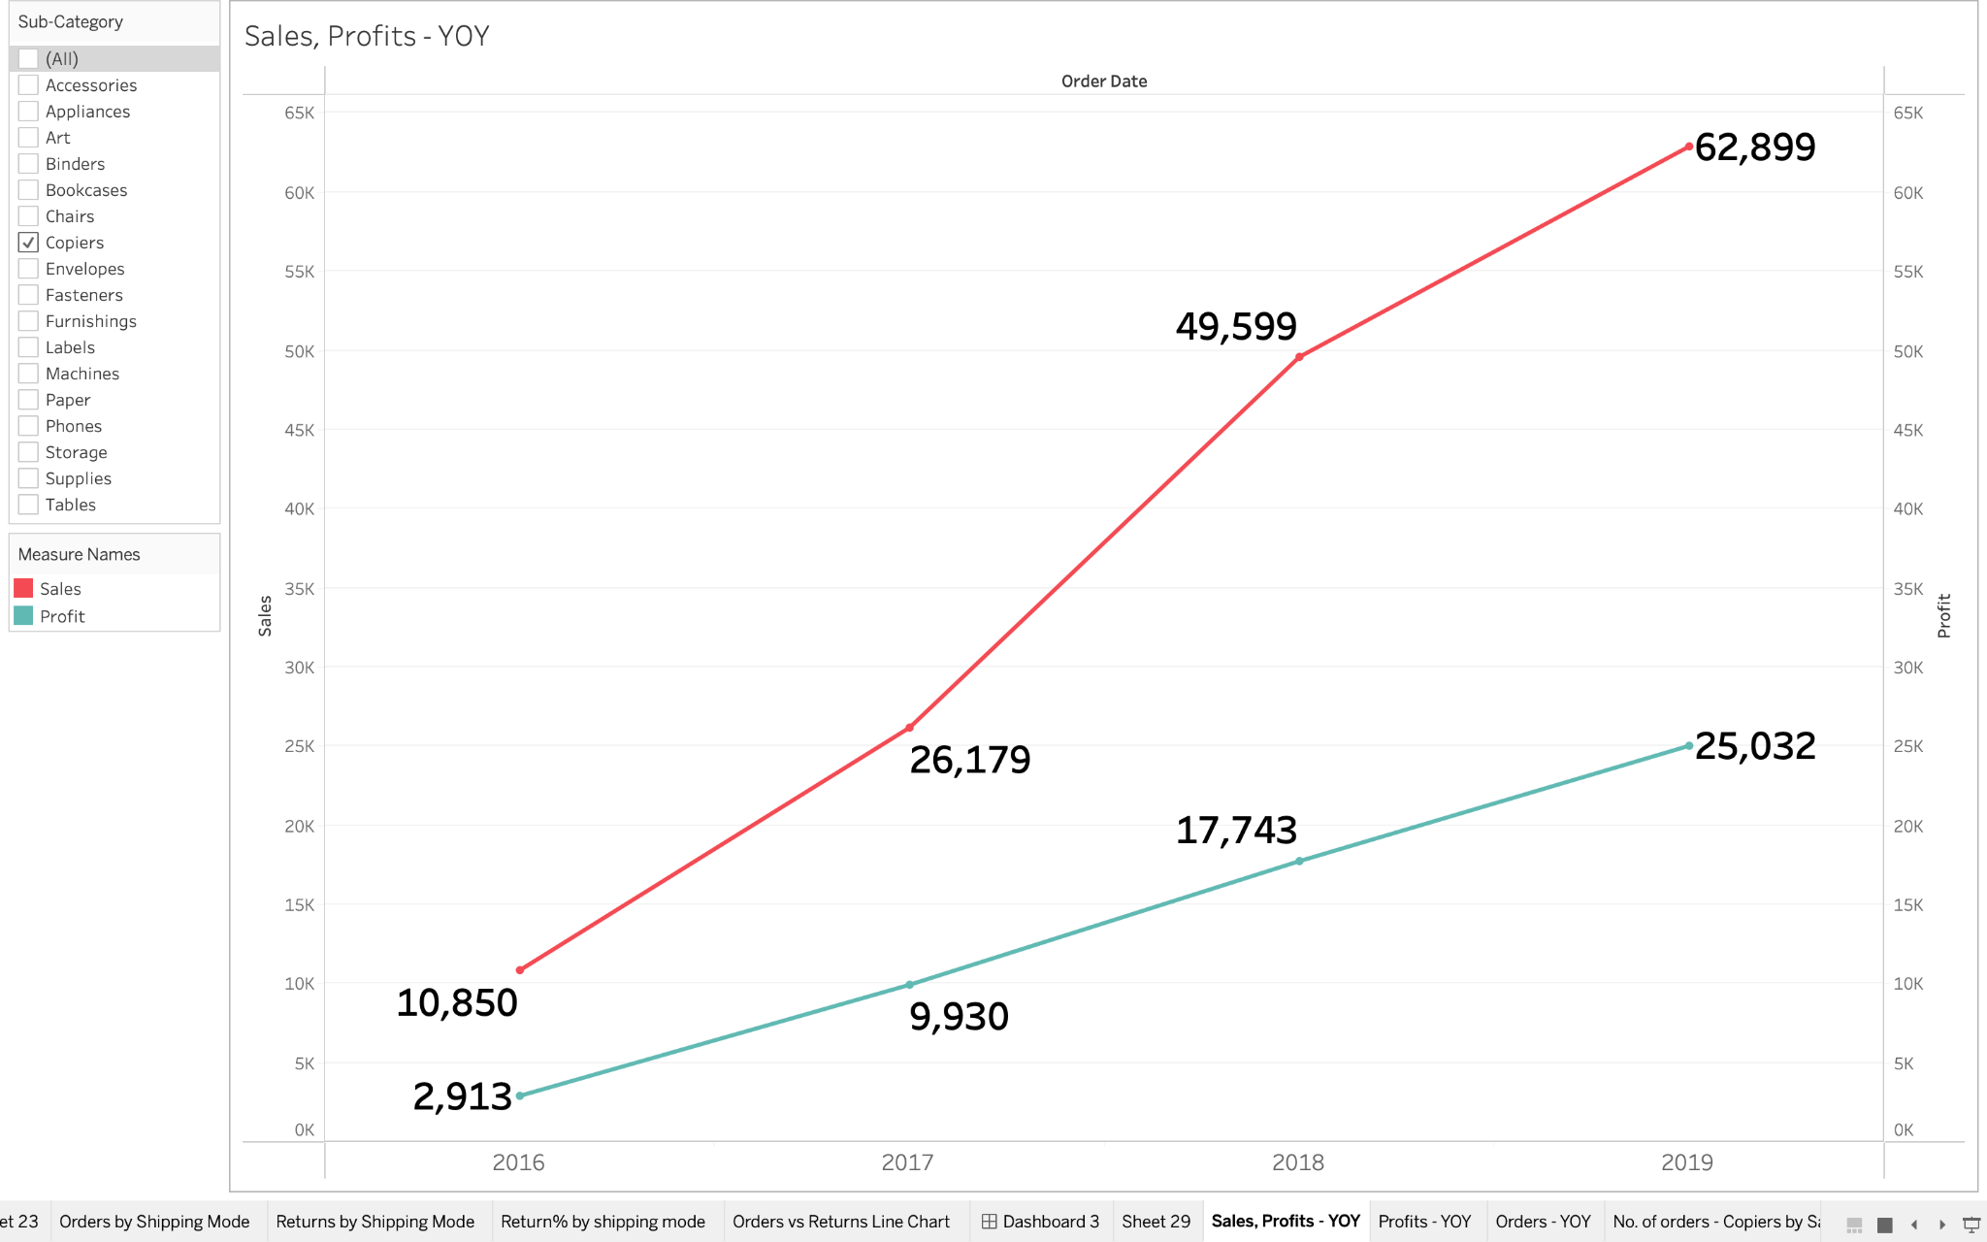

**[5] Total no. of orders fulfilled by Salesperson**

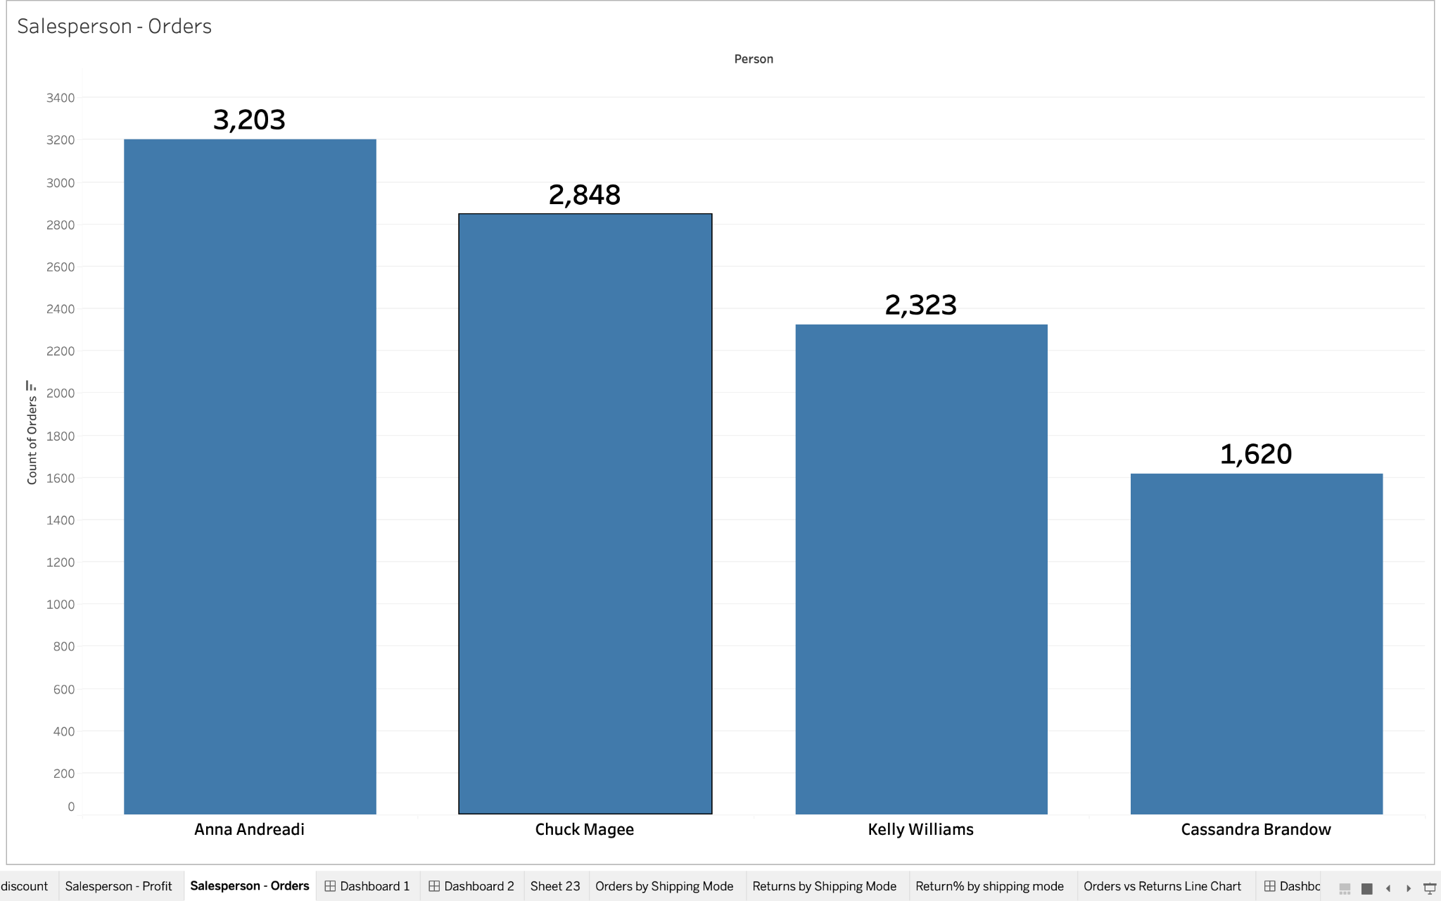

**[6] Orders, returns by monthly basis**

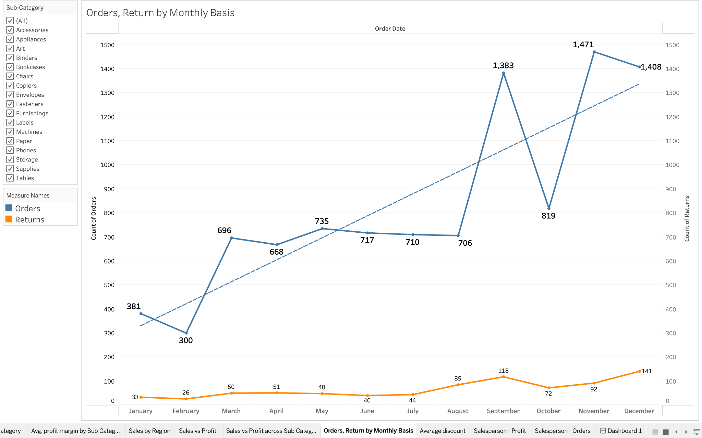

**[7] Orders across Sub-Category. For Profitability, sub-categories with less than 5000$ total profit, have been marked as less profitable.**

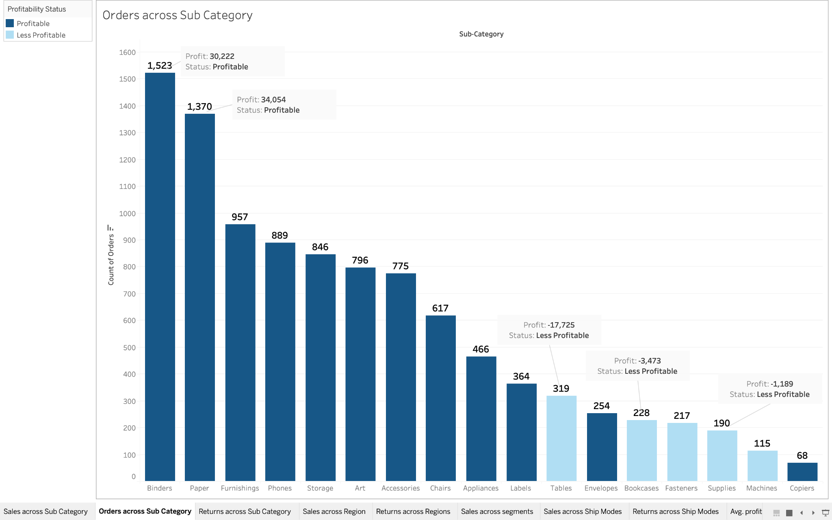

**[8] Average discount rate across sub-categories**

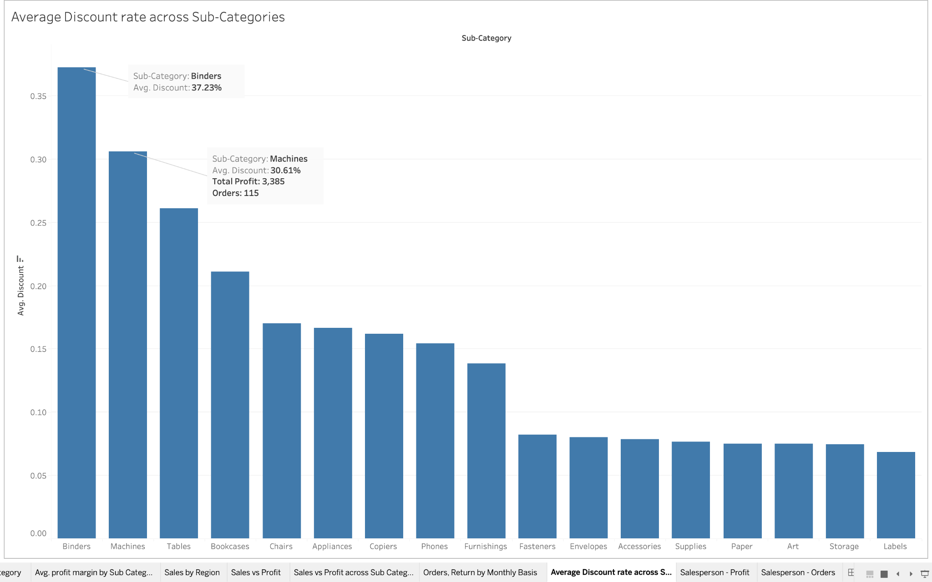

**[9] Sales vs Profit - Scatterplot (Machines)**

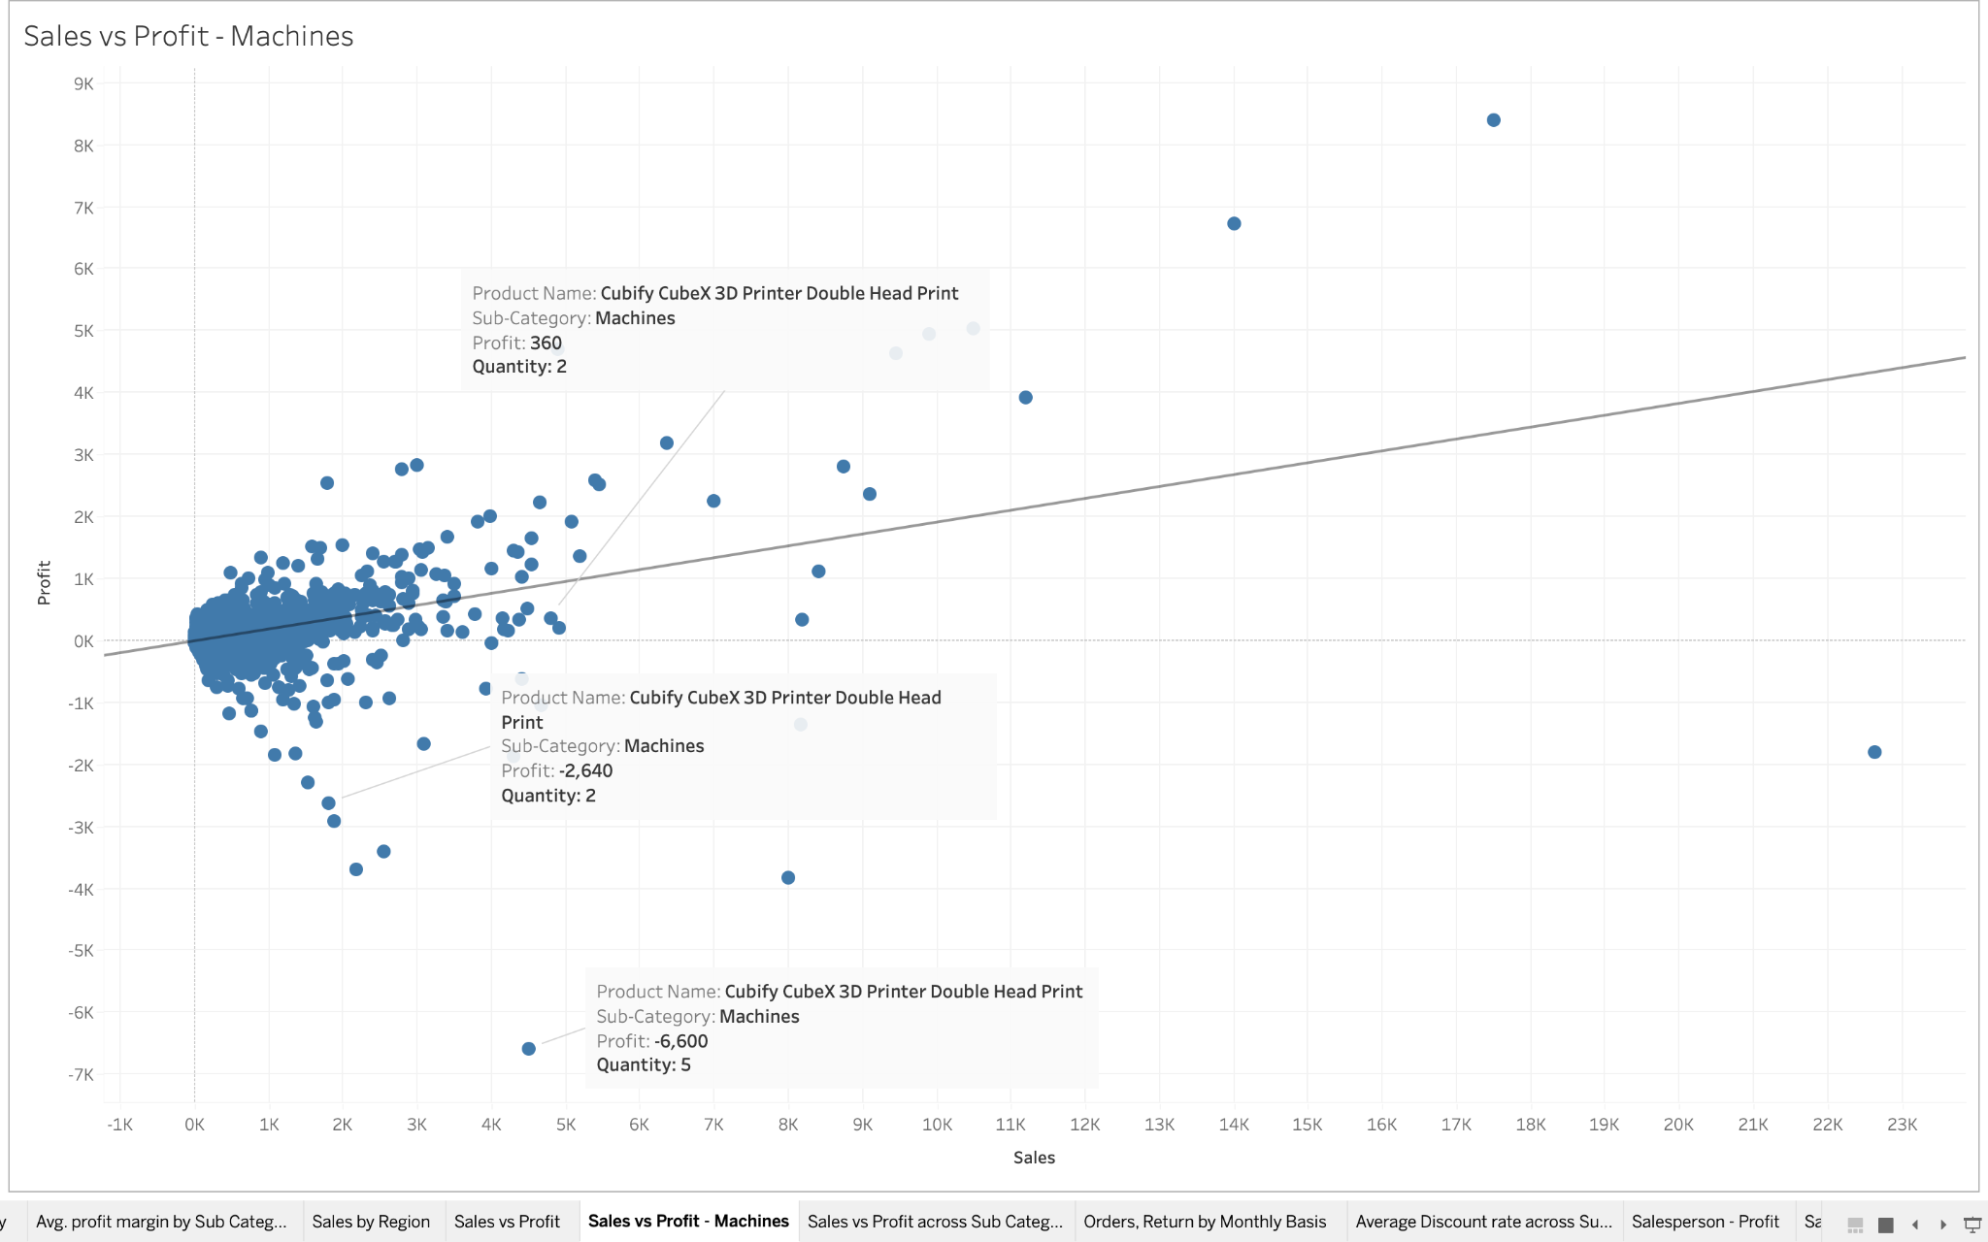

**[10] Orders fulfilled by Shipping Modes**

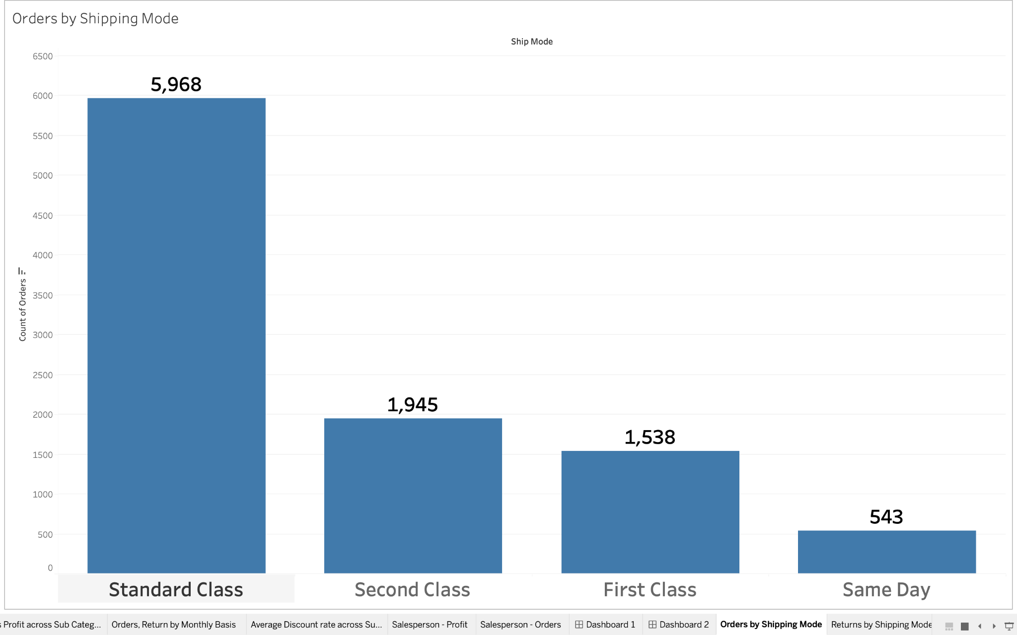

**[11] Return% by shipping mode.**

This is a calculated using - 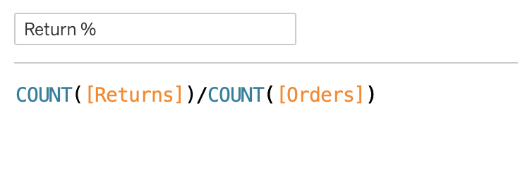

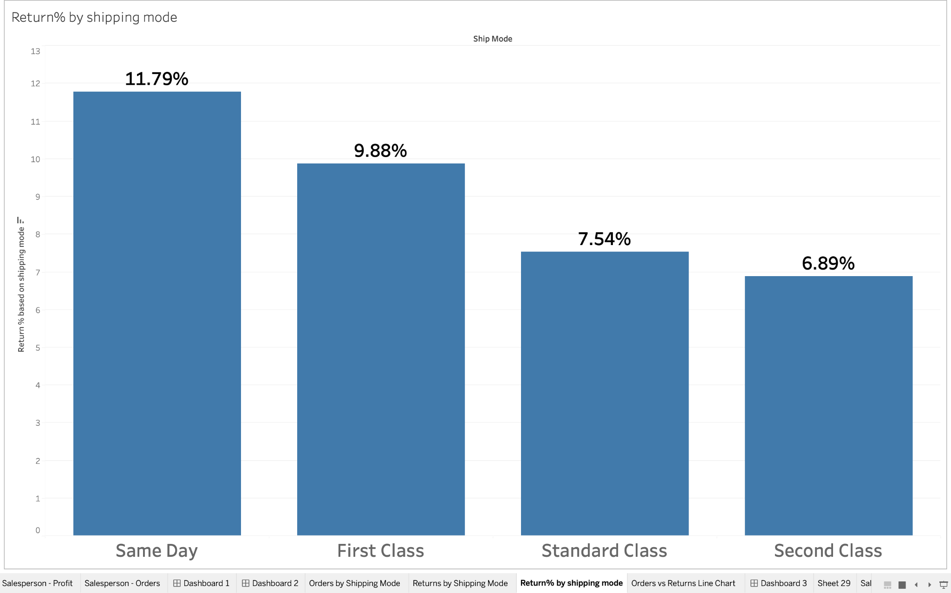

**[12] Sales vs Profit - Scatterplot (Outliers have been identified)**

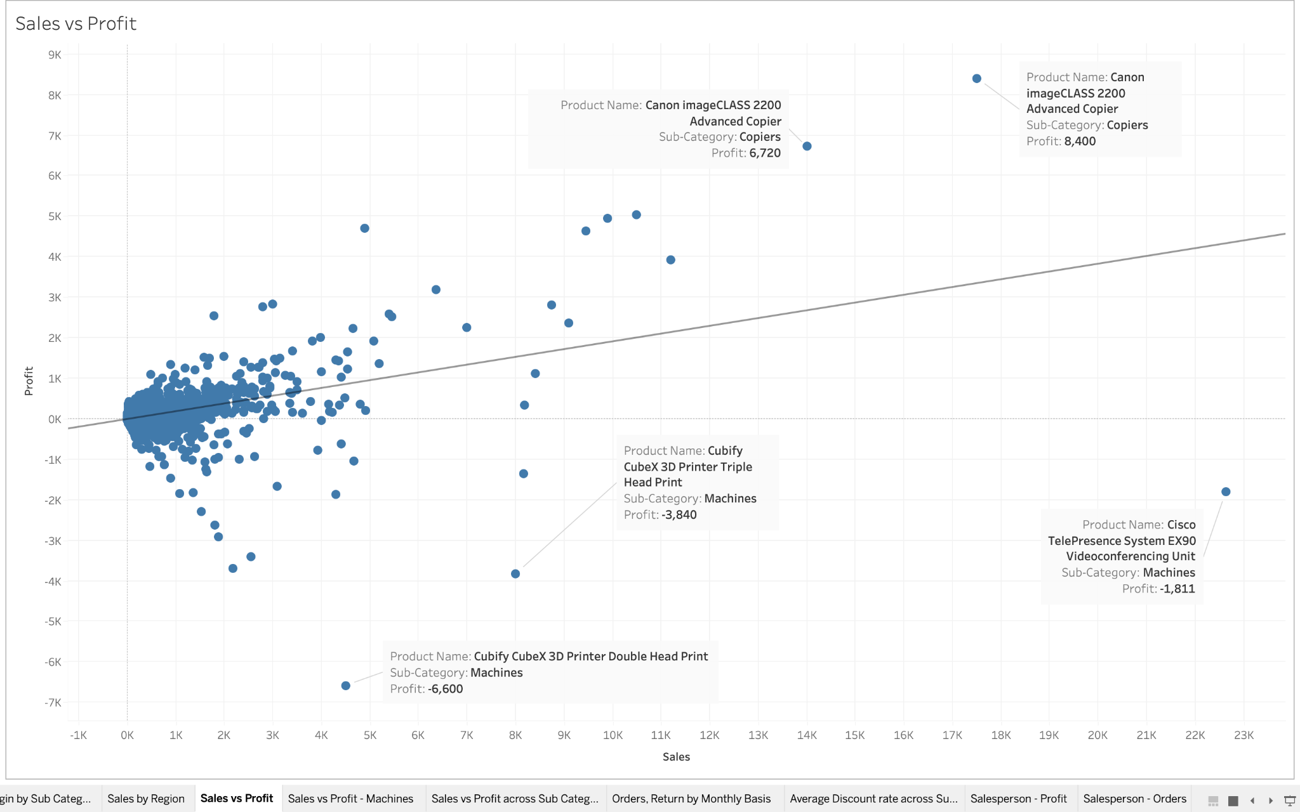

**DASHBOARDS**

**[1] Salesperson Analysis**

Average profit margin by subcategory - Average profit generated by sales person - Orders fulfilled by sales person **(No Pie charts used xD)**

Filter actions have been applied across all sheets in the dashboard.

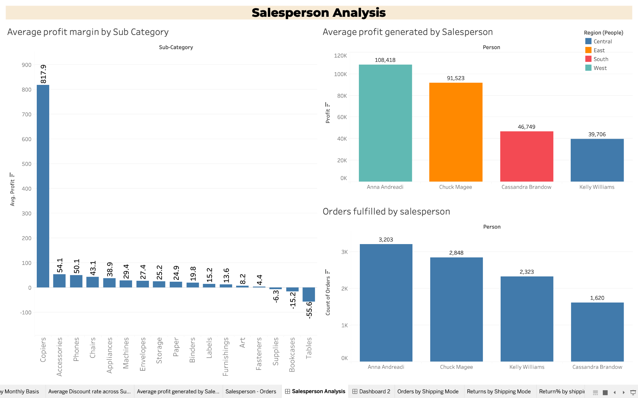

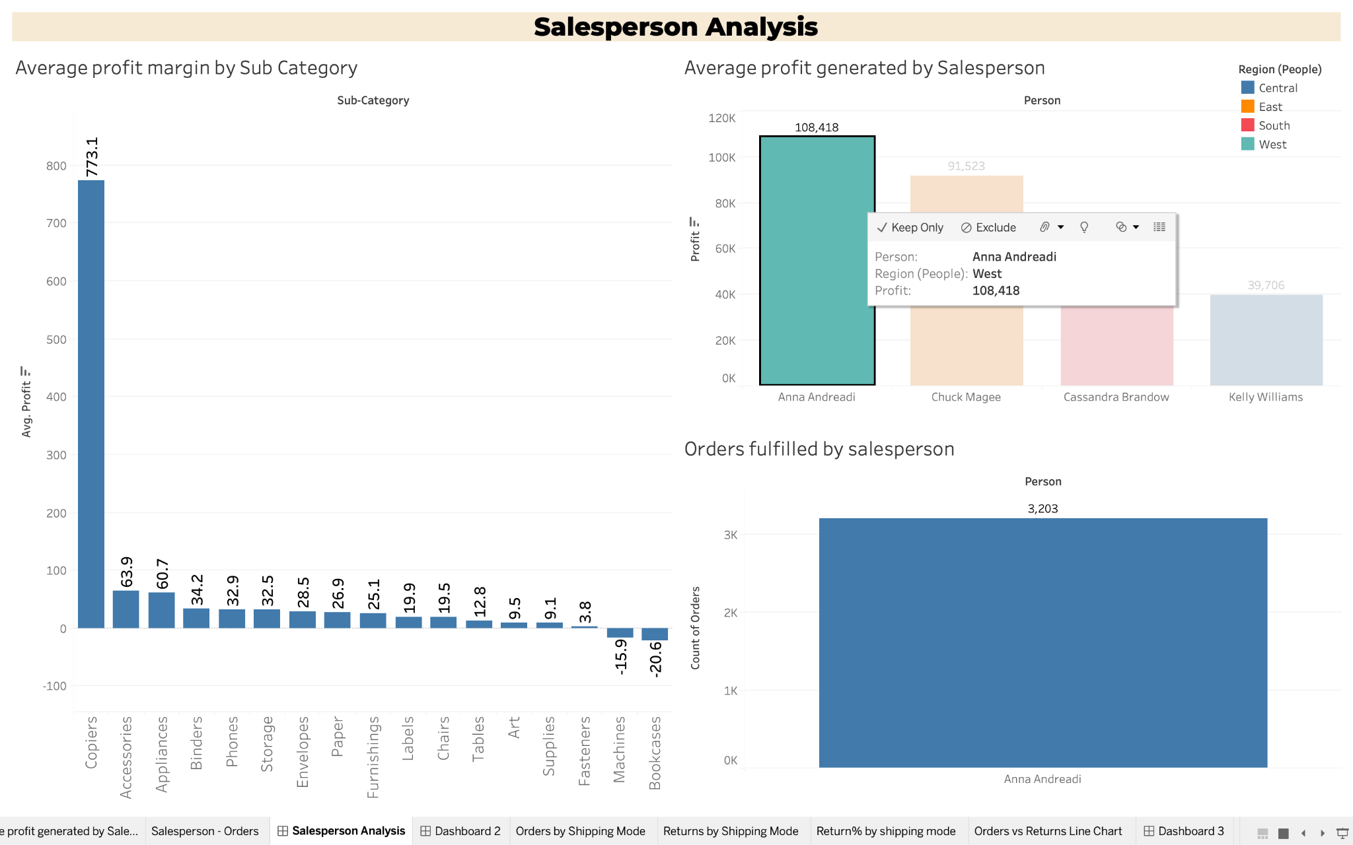

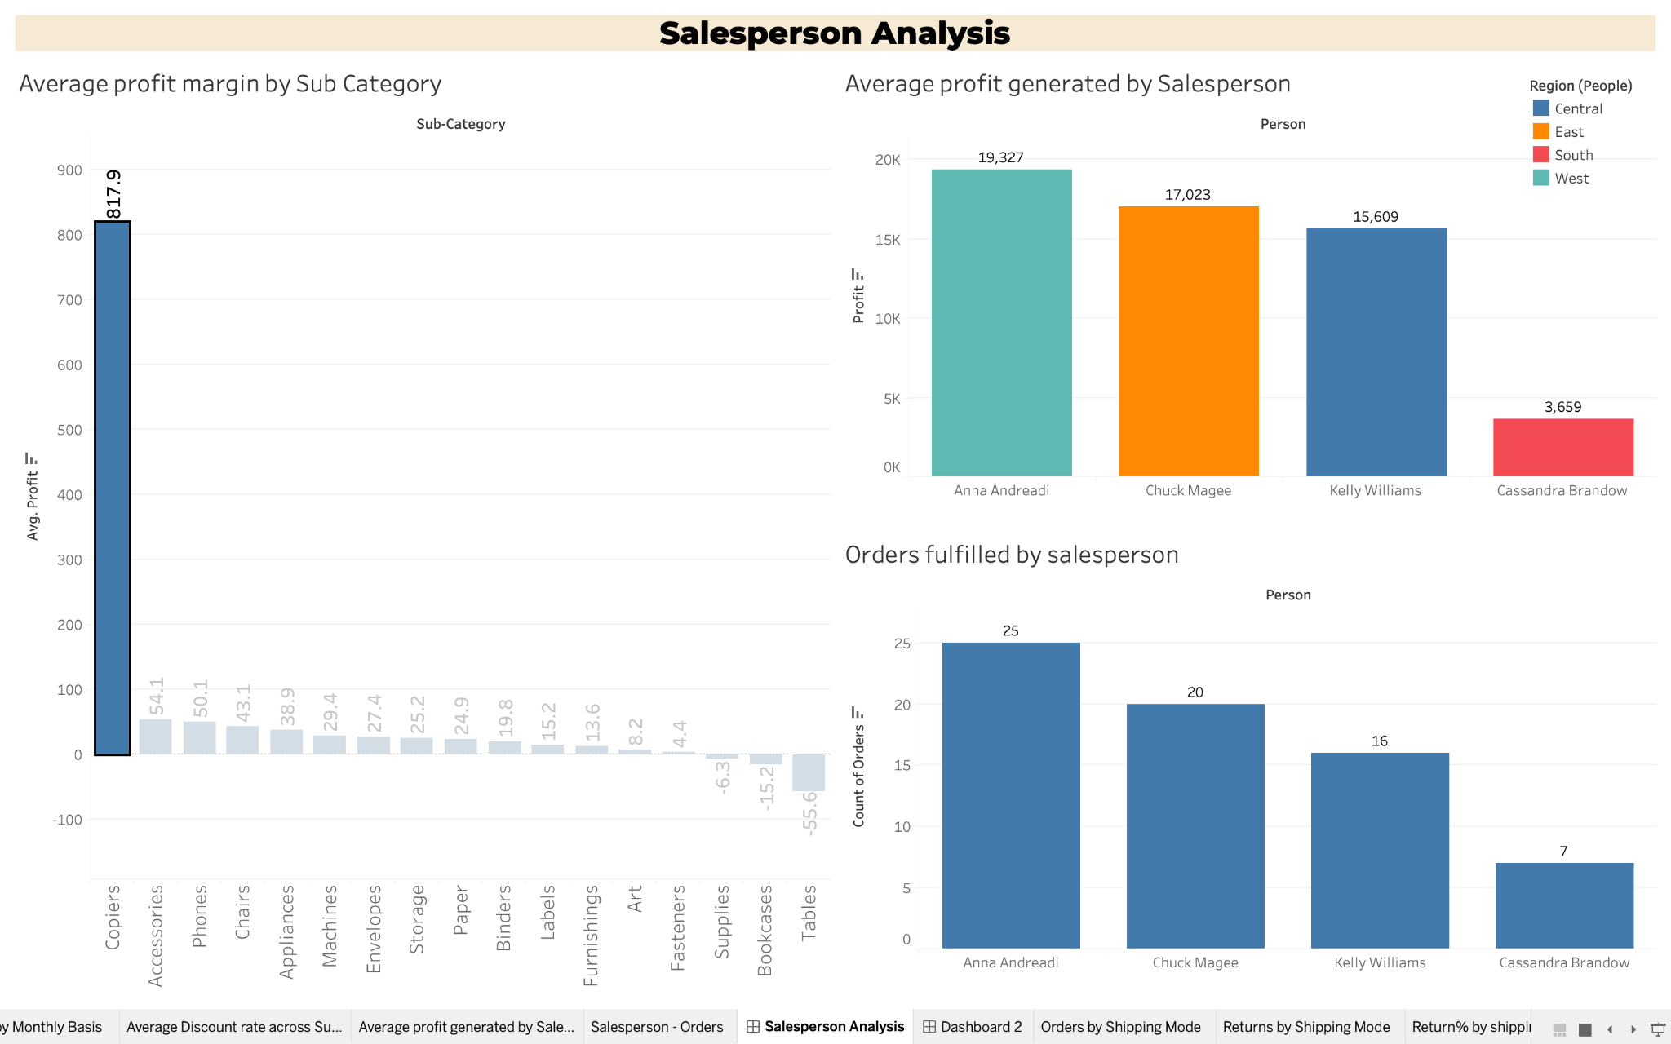

On selecting copiers in the average profit margin by sub category sheet, it is highlighting the no. of copiers sold by each sales person.

https://public.tableau.com/app/profile/abhishek.rathi7775/viz/Hult_SuperStore/SalespersonAnalysis?publish=yes

[2] **Sales Performance Overview**

Sales across USA - Sales based on person - Sales across categories **(No real estate wasted xD)**

Hover actions have been applied across sheets in the dashboard

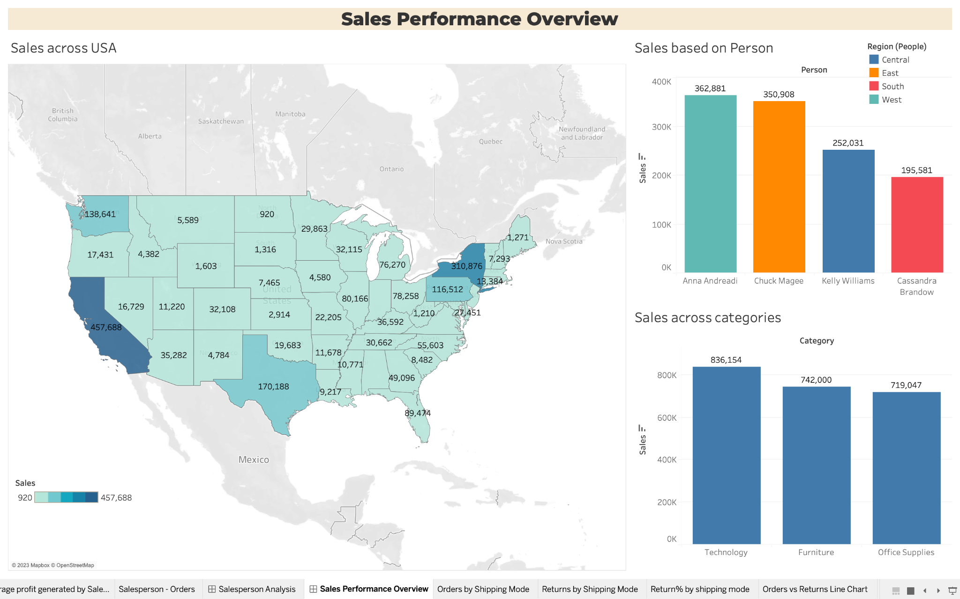

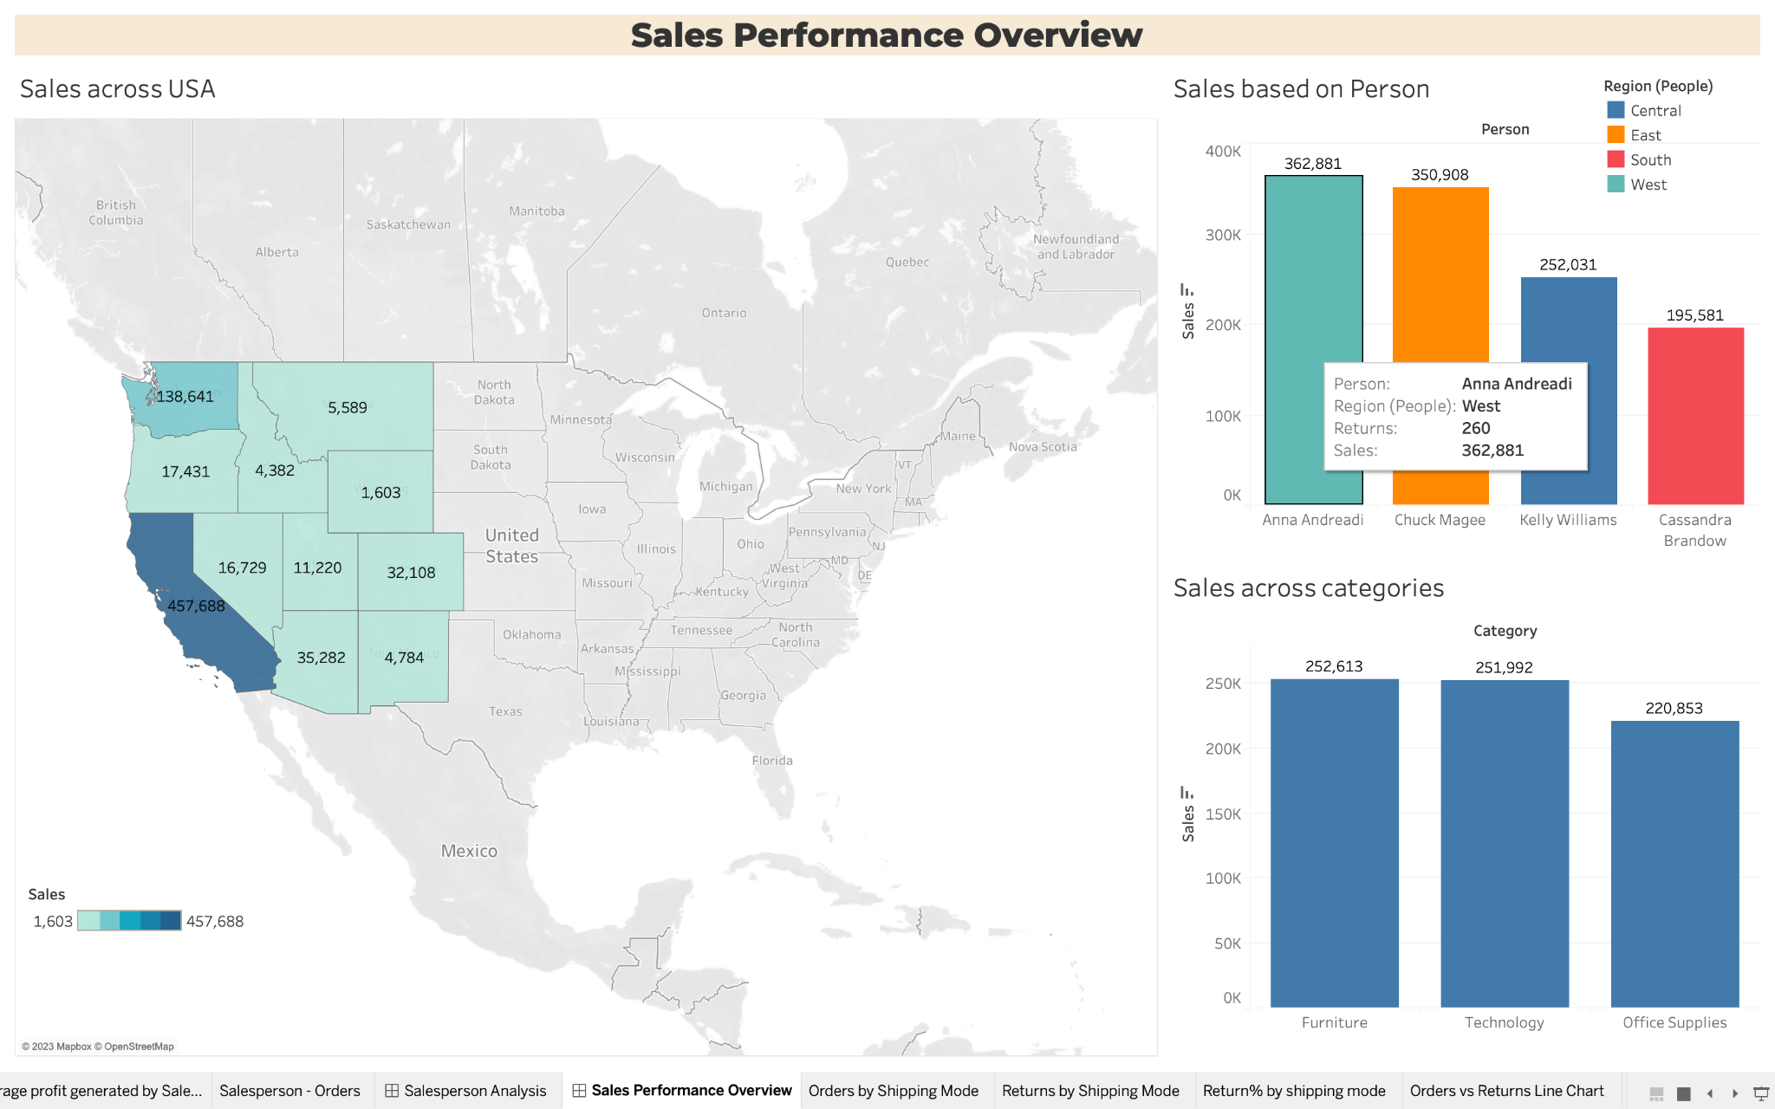

On hovering over Anna Andreadi, the West region is highlighted and sales across categories is updated.

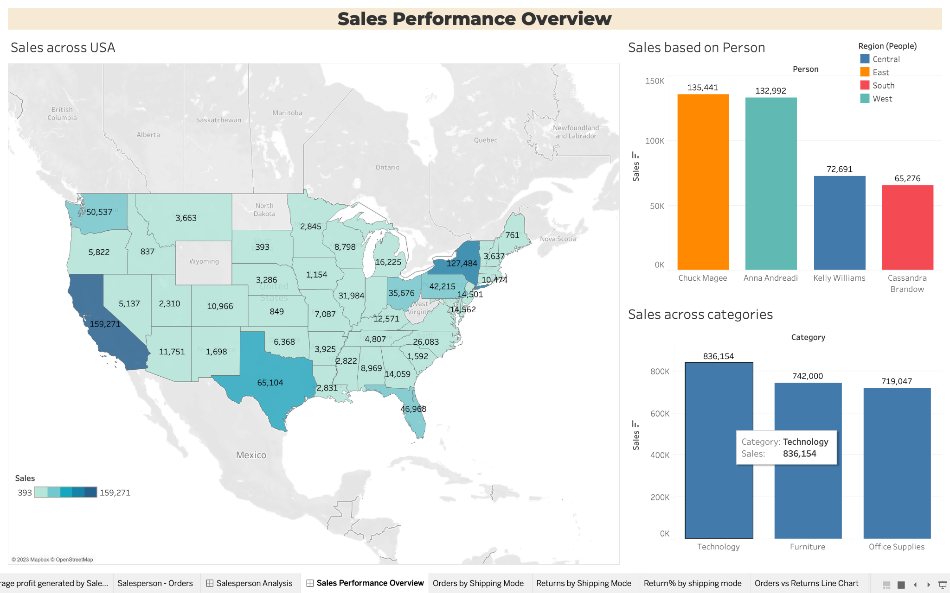

On hovering over technology, regions where technology category products are sold is highlighted and sales revenue generated by each sales person for technology products is updated.

https://public.tableau.com/app/profile/abhishek.rathi7775/viz/Hult_SuperStore/SalesPerformanceOverview?publish=yes

**[3] The Ebb and Flow of Orders & Returns**

Order,Returns by Monthly basis - Orders by Shipping mode - Returns by Shipping mode - Returns% by Shipping Mode

Combination of filter and hover actions have been applied across sheets.

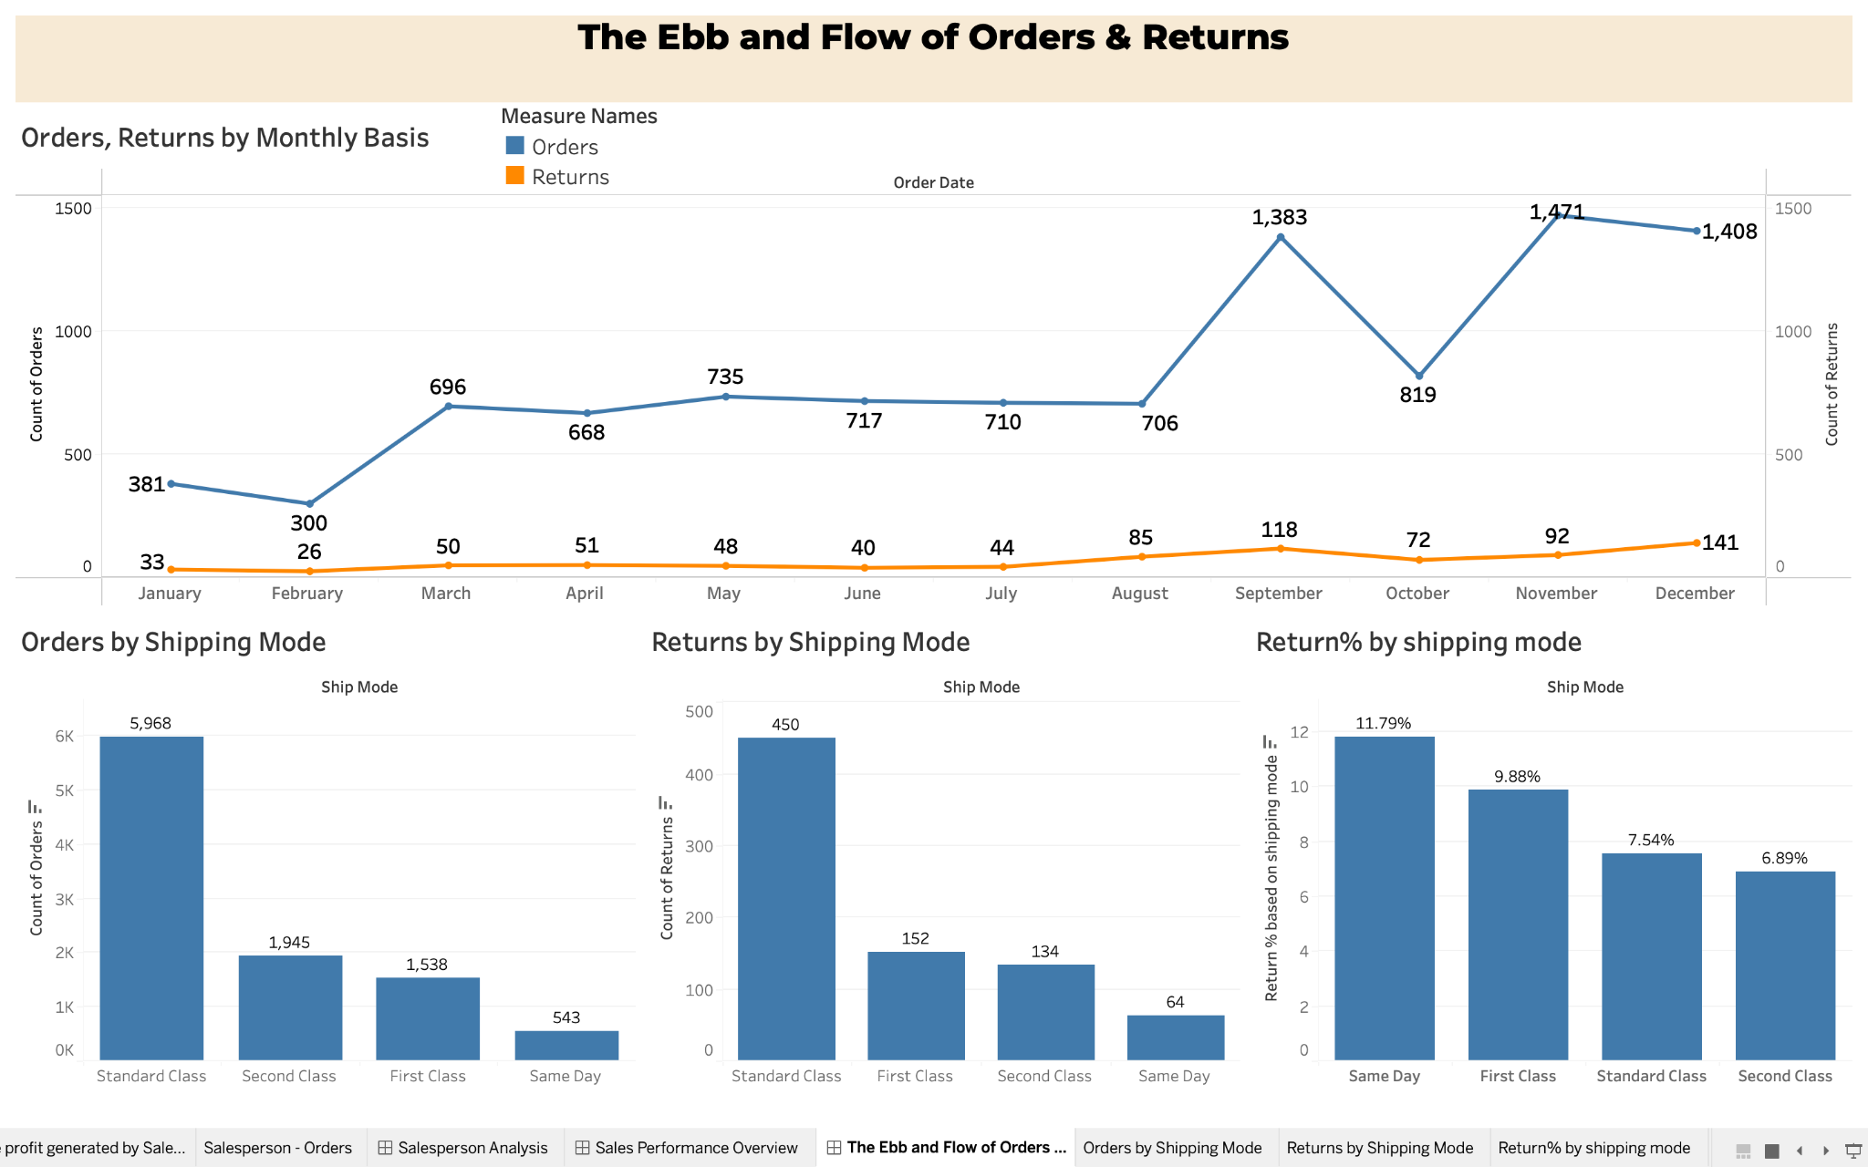

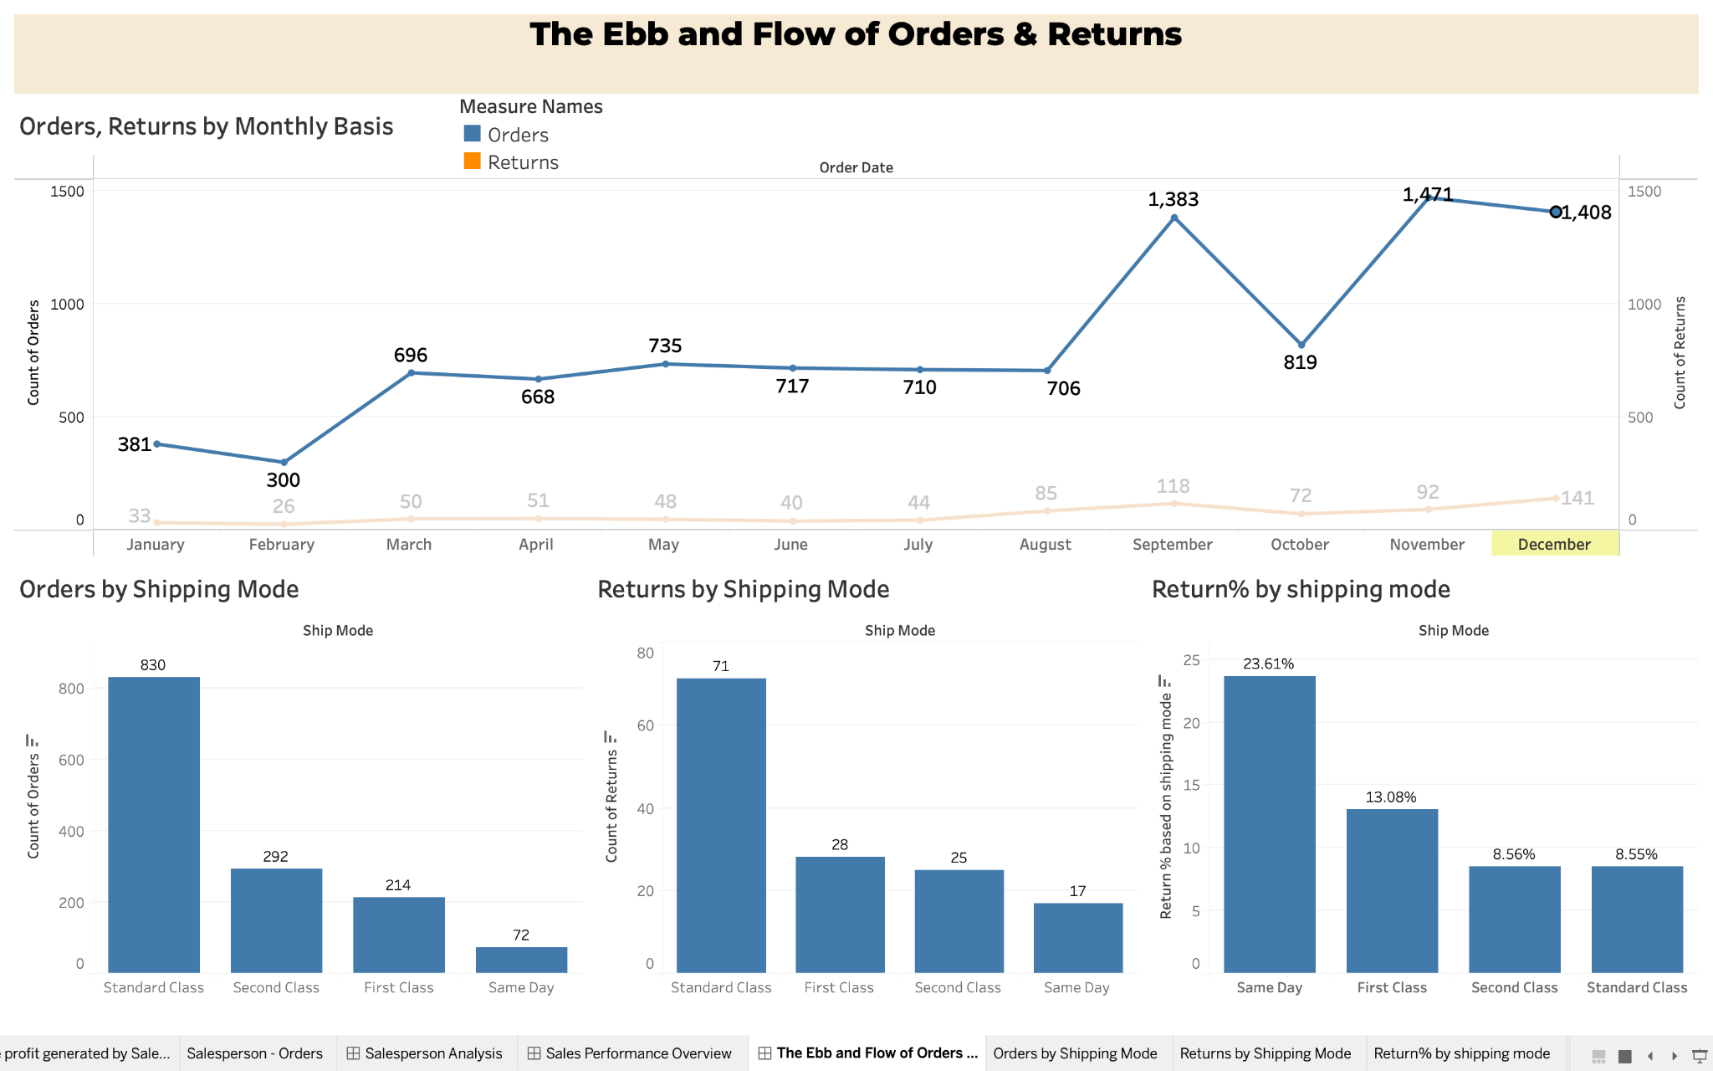

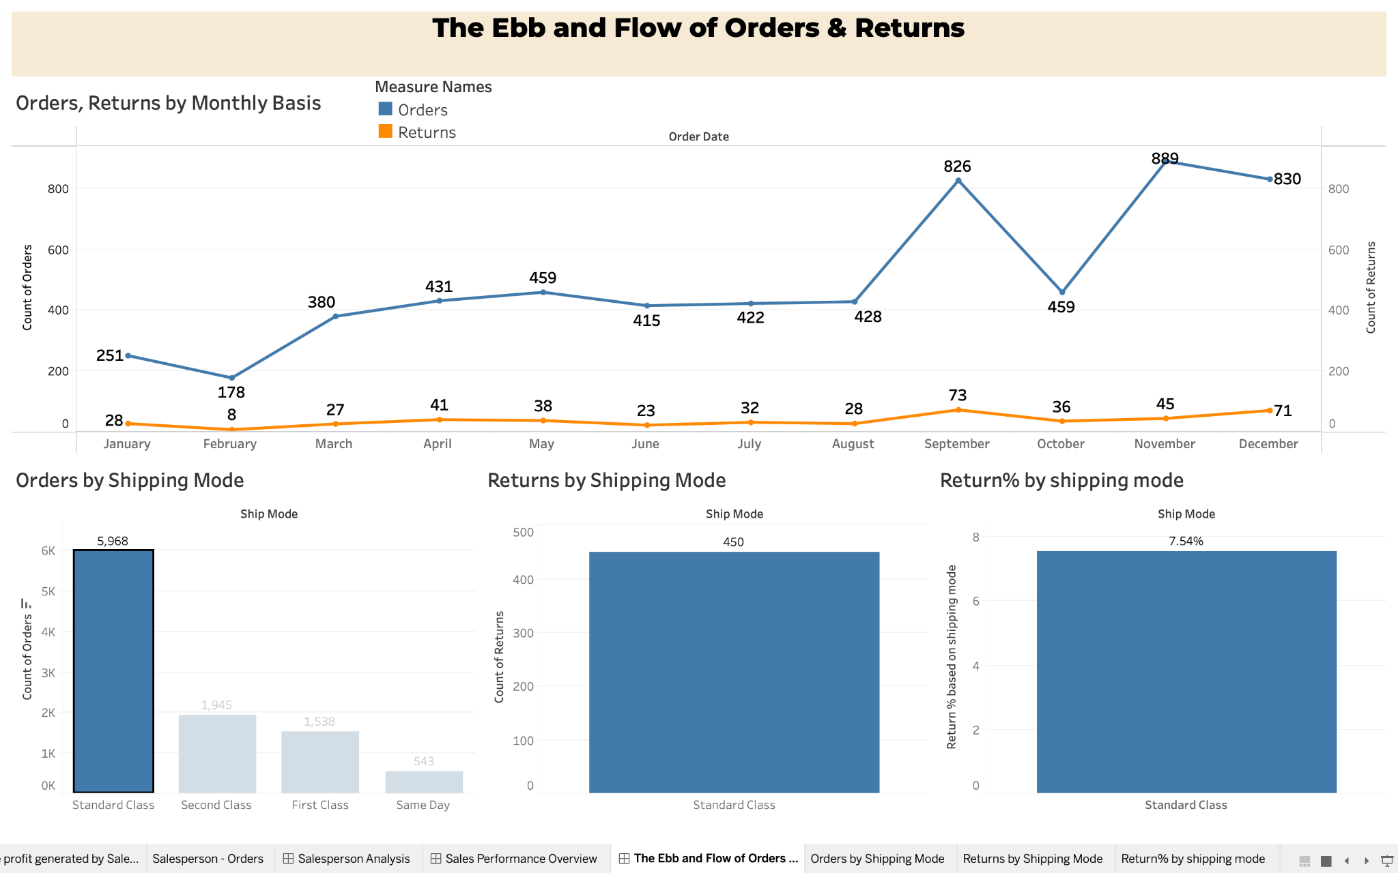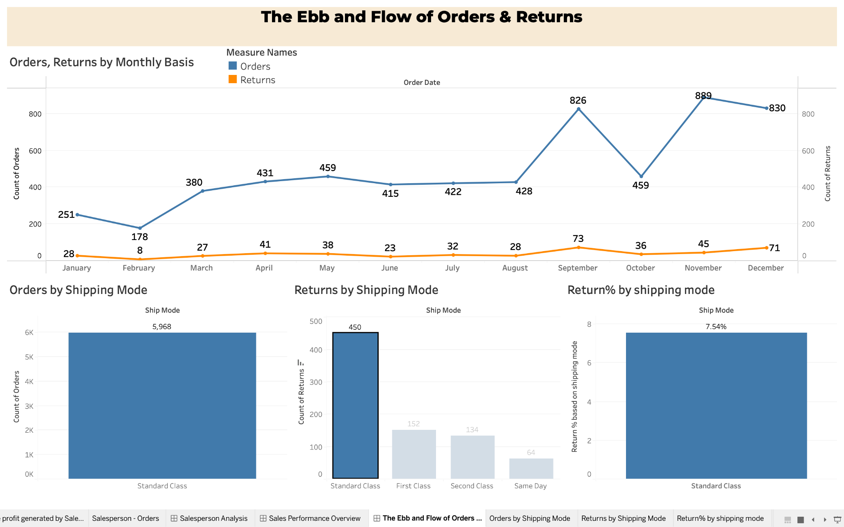

https://public.tableau.com/app/profile/abhishek.rathi7775/viz/Hult_SuperStore/TheEbbandFlowofOrdersReturns?publish=yes

**[4] Sales vs Profit: A Comprehensive Analysis**

Average discount rate across subcategories - Sales vs Profit scatterplot - Profits YOY - Orders YOY

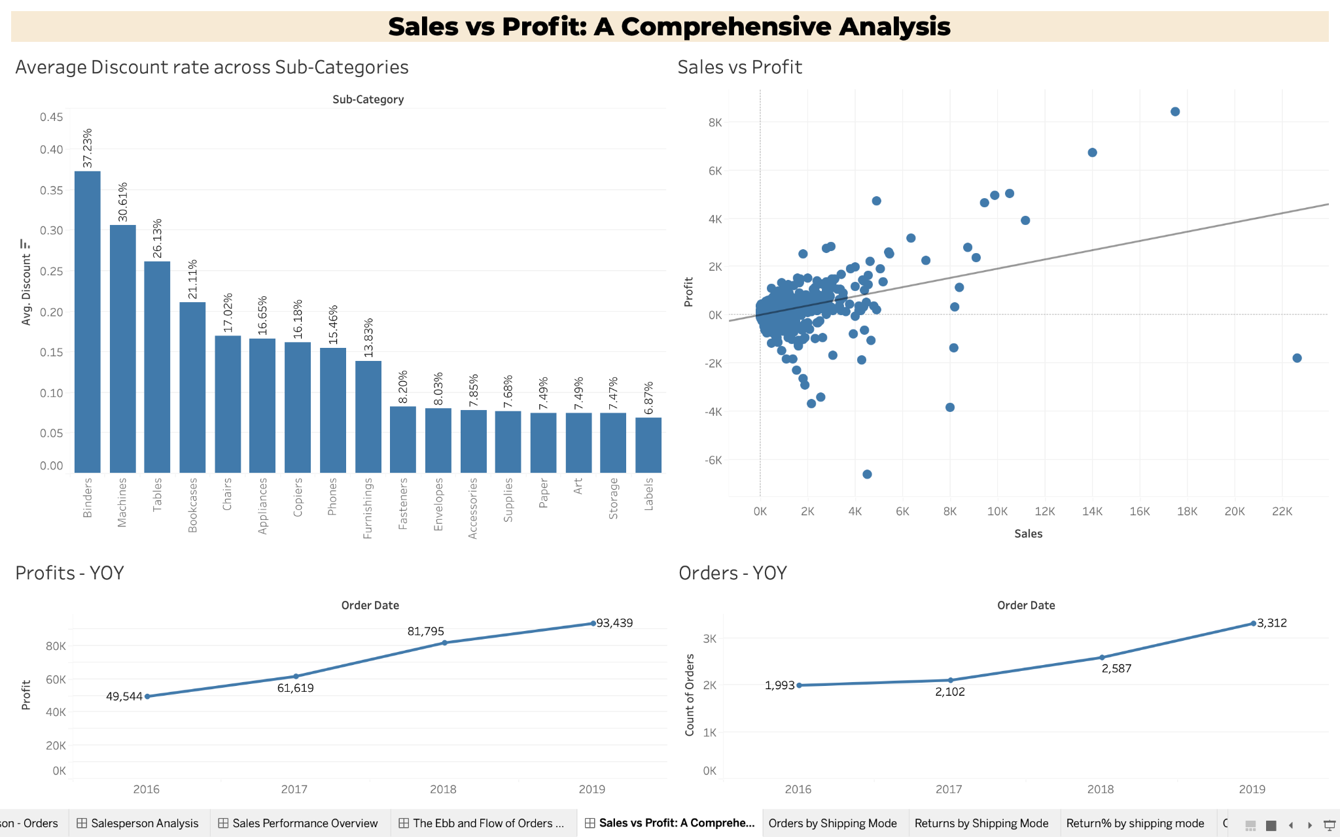

Machines have a 30% discount rate, still the Profits Y-O-Y fell drastically to (-2,869) in 2019. 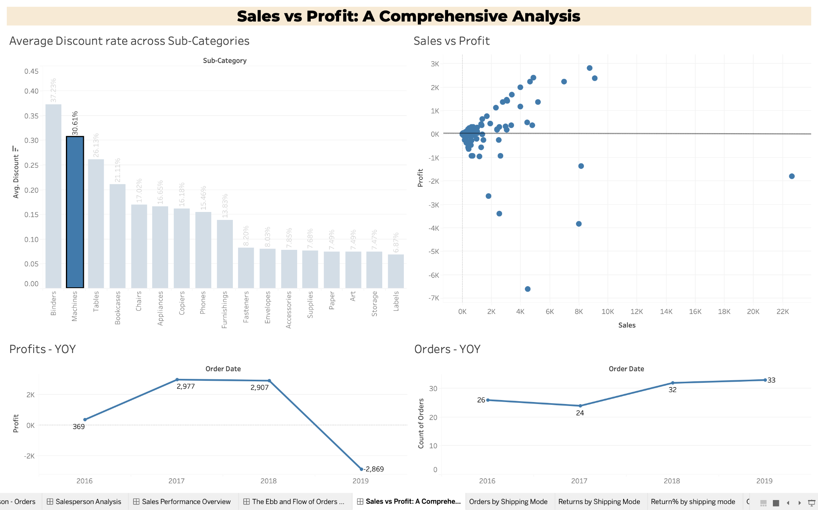

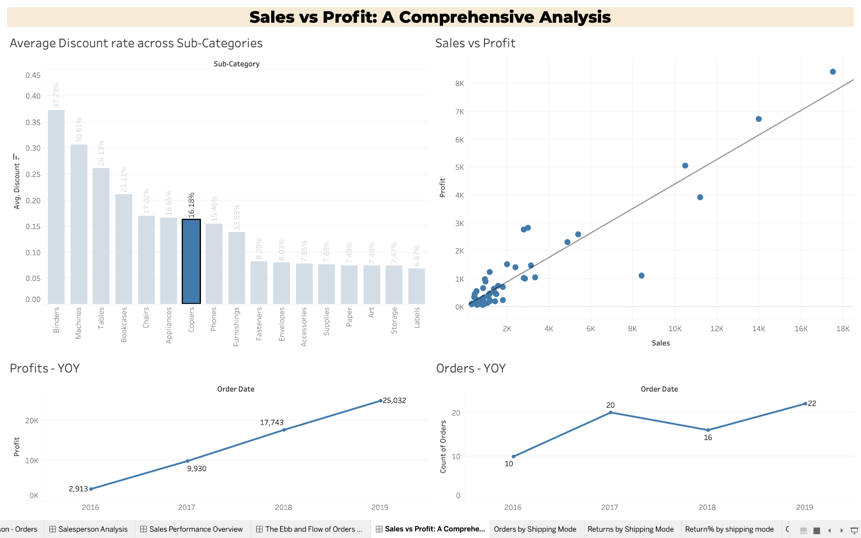

Our STAR product - Copiers show a tremendous growth in Profits YOY, generating a huge profit of 25,032$ in 2019.

<https://public.tableau.com/app/profile/abhishek.rathi7775/viz/Hult_SuperStore/SalesvsProfitAComprehensiveAnalysis?publish=yes>

**STORY - Unlocking the Secrets to Skyrocket Your Business**

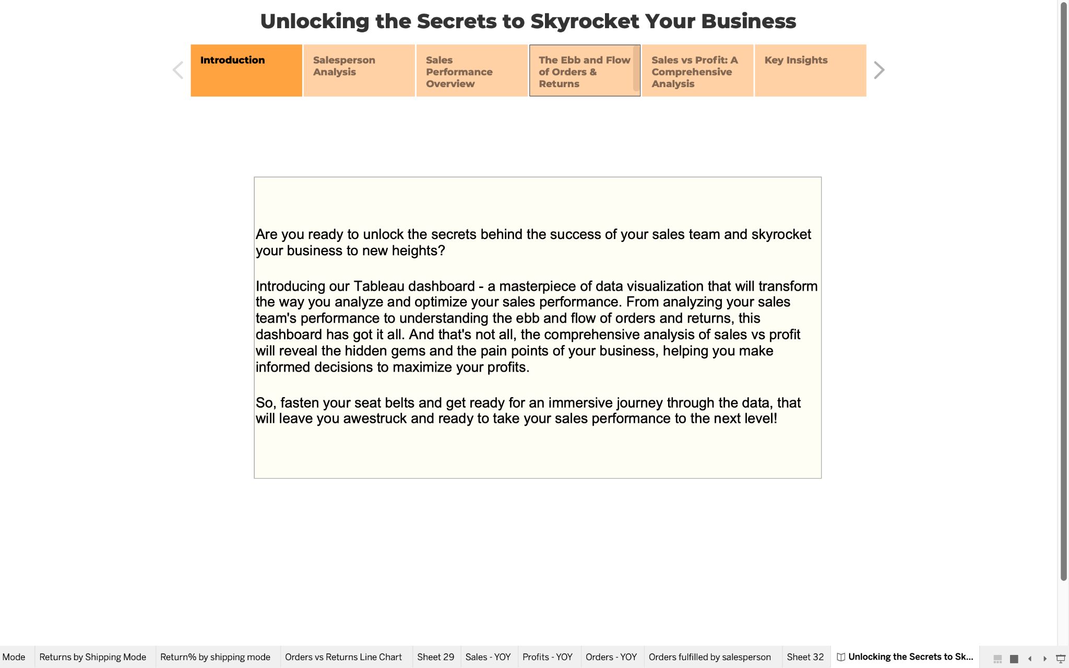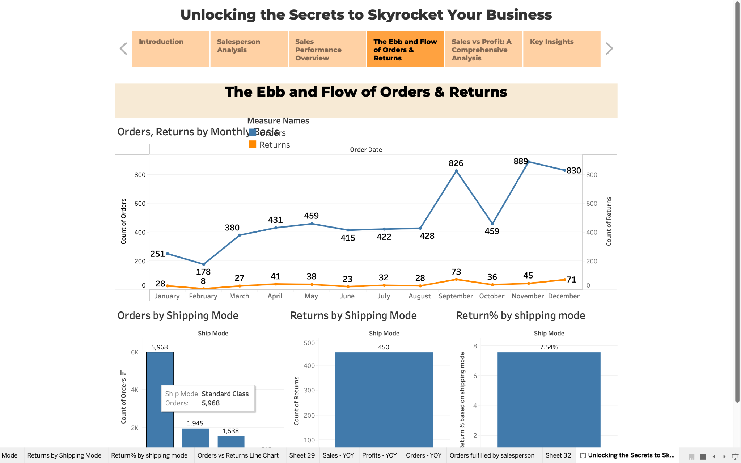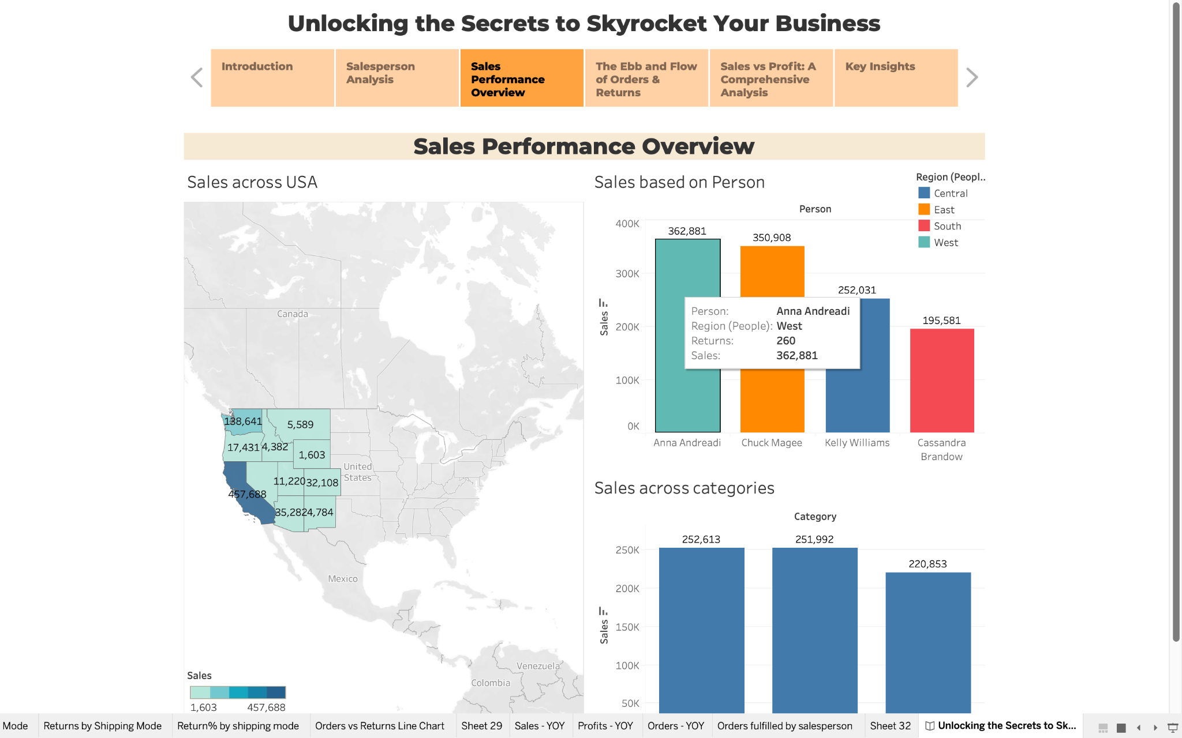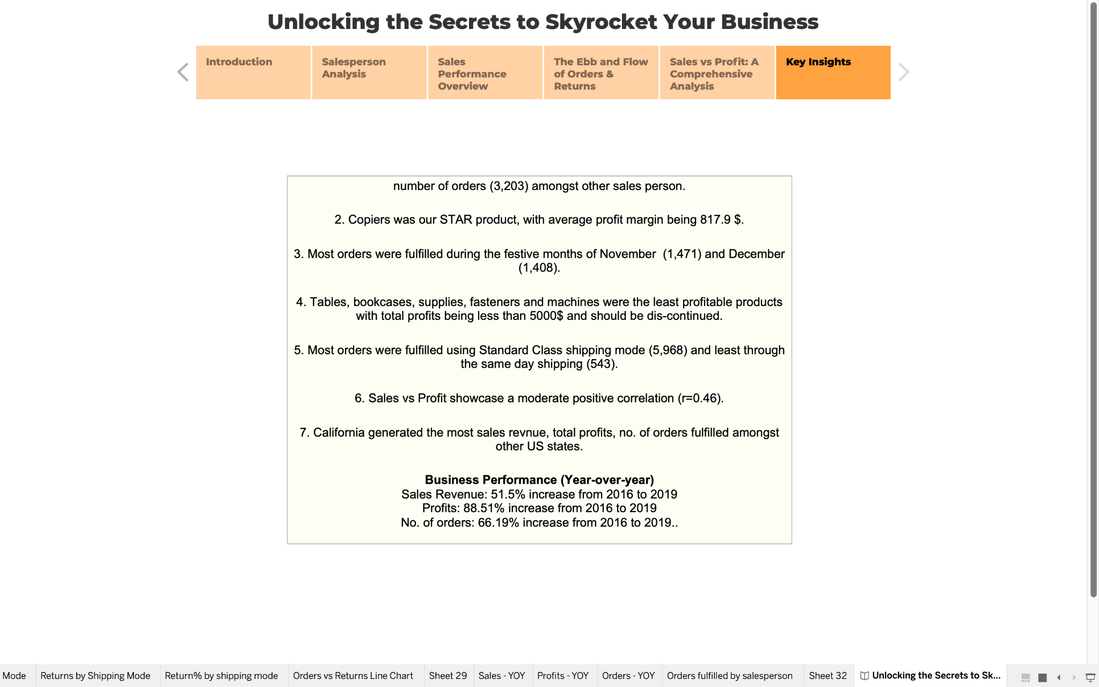

**REFERENCES**

[1] Green, A. (2023, January 23). *The 16 biggest online shopping events across the world every retailer needs to know about*. Crimtan. <https://www.crimtan.com/blog/the-16-biggest-online-shopping-events-across-the-world-every-retailer-needs-to-know-about/>

[2] *California's population*. (2022, June 28). Public Policy Institute of California. <https://www.ppic.org/publication/californias-population/>

[3] *Economy of California*. (2023, March 3). Wikipedia, the free encyclopedia. Retrieved March 5, 2023, from <https://en.wikipedia.org/wiki/Economy_of_California#:~:text=The%20economy%20of%20the%20State,national%20economy%20in%20the%20world>